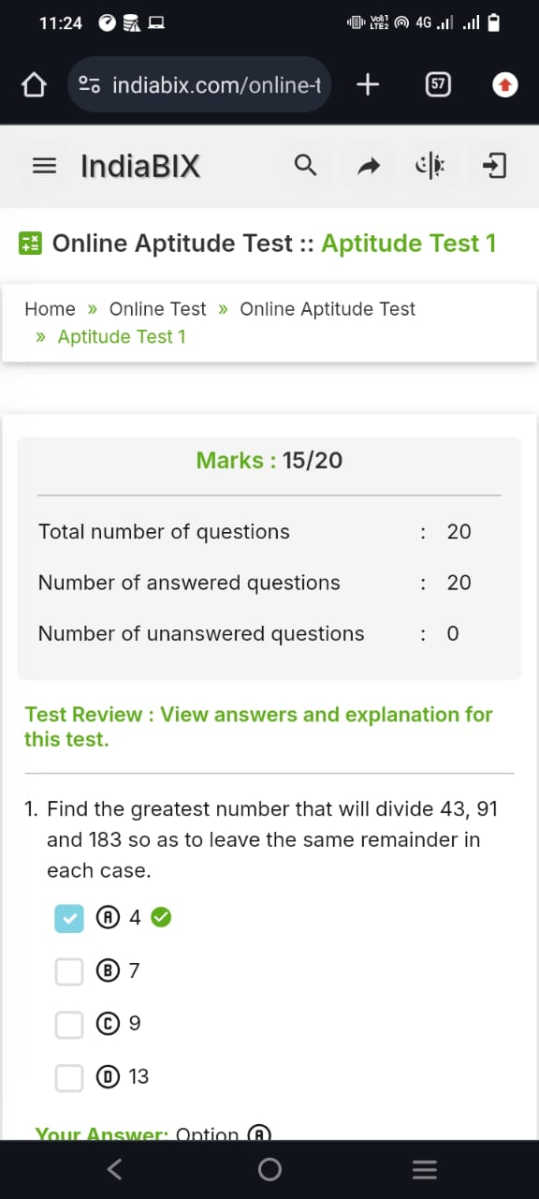

Task 2: Presentation / Self Elevator pitch Video

https://youtu.be/57tvtLcamkE?si=hd87-QpDKWXKpBM8